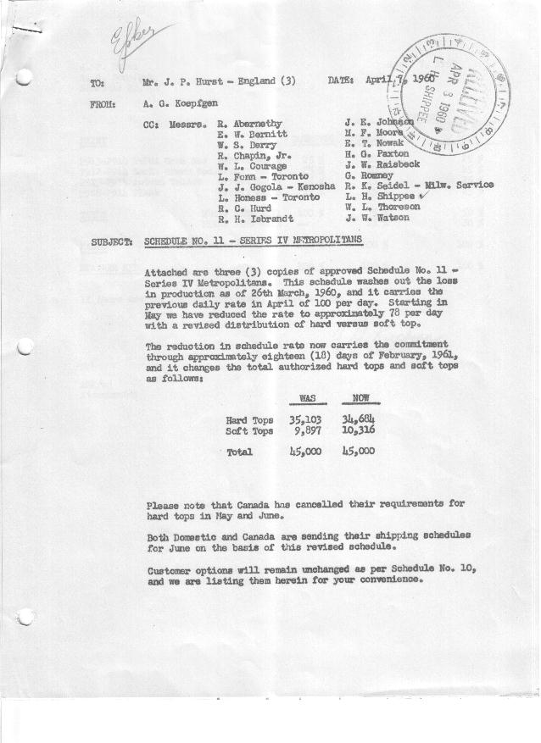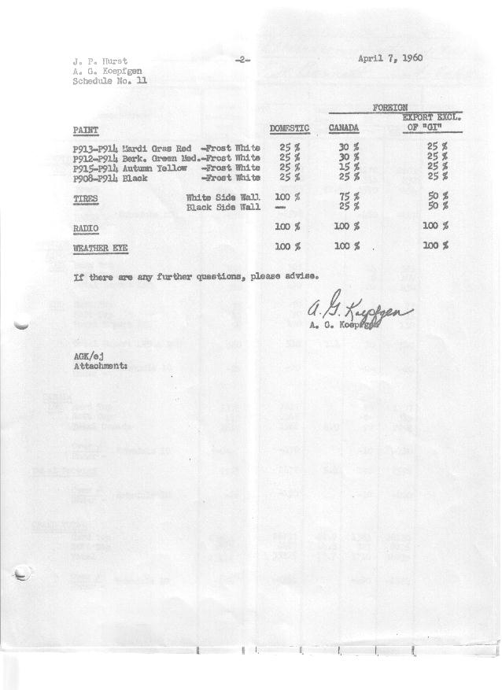

FORM AM 1262 Page 1 of 2 APPROVED R. Abernethy (signed) DATE 4-8-60

SCHEDULE NO. ______11 ___ DATE 4-6-60 MONTHLY BUILDING SCHEDULE APPROVED R. W.Chapin Jr. (signed) DATE_ 4.8.60 _
REVISION NO. _______ __ ____ DATE PRODUCT APPROVED E.W.Bernitt (signed) DATE _ 4-8-60 ____
SERIES IV 1500 c.c. ENGINE
METROPOLITAN SERIES CARS – AUSTIN MOTORS CO., LTD, ENGLAND
DESCRIPTION | BUILT  ◻ACT EST  THRU  MARCH | FIRM BUILDING SCHEDULE  (FABRICATED MATERIAL RELEASE) |  |  |  |  |  |  |  |  |  |  |  |  |  |  | TENTATIVE SCHEDULE  (RAW MATERIAL RELEASED) |  |  | GRAND  TOTAL
DESCRIPTION | BUILT  ◻ACT EST  THRU  MARCH | MONTH APRIL  DAYS 19 |  |  | MONTH MAY  DAYS 22 |  |  | MONTH JUNE  DAYS 20 |  |  | MONTH JULY  DAYS 16 |  |  | MONTH AUGUST  DAYS 18 |  |  | MONTH SEPTEMBER  DAYS 22 |  |  | GRAND  TOTAL
DESCRIPTION | BUILT  ◻ACT EST  THRU  MARCH | DAILY | MONTH | CUM’L  TOTAL | DAILY | MONTH | CUM’L  TOTAL | DAILY | MONTH | CUM’L  TOTAL | DAILY | MONTH | CUM’L  TOTAL | DAILY | MONTH | CUM’L  TOTAL | DAILY | MONTH | CUM’L TOTAL | GRAND  TOTAL
DOMESTIC LHD:
Hard-Top | 19970 |  | 989 | 20959 |  | 984 | 21943 |  | 1018 | 22961 |  | 814 | 23775 |  | 968 | 24743 |  | 1272 | 26015
Soft-Top | 5468 |  | 791 | 6259 |  | 651 | 6910 |  | 507 | 7417 |  | 271 | 7688 |  | 322 | 8010 |  | 318 | 8328
Total U.S. | 25438 | 93.7 | 1780 | 27218 | 74.3 | 1635 | 28853 | 76.3 | 1525 | 30378 | 67.8 | 1085 | 31463 | 71.7 | 1290 | 32753 | 72.3 | 1590 | 34343
Over/(Under) Schedule 10 | (474) |  | -0- | (474) |  | (430) | (904) |  | (335) | (1239) |  | (355) | (1594) |  | (400) | (1994) |  | (480) | (2474)
FOREIGN:
EXPORT LHD Hard-Top | 237 |  | 14 | 251 |  | 14 | 265 |  | 14 | 279 |  | 14 | 293 |  | 14 | 307 |  | 14 | 321
Soft-Top | 73 |  | 6 | 79 |  | 6 | 85 |  | 6 | 91 |  | 6 | 97 |  | 6 | 103 |  | 6 | 109
Total Export LHD | 310 |  | 20 | 330 |  | 20 | 350 |  | 20 | 370 |  | 20 | 390 |  | 20 | 410 |  | 20 | 430
RHD Hard Top | 35 |  | 7 | 42 |  | 7 | 49 |  | 7 | 56 |  | 7 | 63 |  | 7 | 70 |  | 7 | 77
Soft Top | 15 |  | 3 | 18 |  | 3 | 21 |  | 3 | 24 |  | 3 | 27 |  | 3 | 30 |  | 3 | 33
Total Export RHD | 50 |  | 10 | 60 |  | 10 | 70 |  | 10 | 80 |  | 10 | 90 |  | 10 | 100 |  | 10 | 110
Total Export LHD & RHD | 360 | 1.6 | 30 | 390 | 1.4 | 30 | 420 | 1.5 | 30 | 450 | 1.9 | 30 | 480 | 1.7 | 30 | 510 | 1.4 | 30 | 540
Over/(Under) Schedule 10 | (20) |  | -0- | (20) |  | -0- | (20) |  | -0- | (20) |  | -0- | (20) |  | -0- | (20) |  | -0- | (20)
CANADA Hard-Top | 1372 |  | 35 | 1407 |  | -0- | 1407 |  | -0- | 1407 |  | 130 | 1537 |  | 80 | 1617 |  | 90 | 1707
Soft-Top | 245 |  | 55 | 300 |  | 45 | 345 |  | -0- | 345 |  | -0- | 345 |  | -0- | 345 |  | -0- | 345
Total Canada | 1617 | 4.7 | 90 | 1707 | 2.0 | 45 | 1752 | 0.0 | -0- | 1752 | 8.1 | 130 | 1882 | 4.4 | 80 | 1962 | 4.0 | 90 | 2052
Over/(Under) Schedule 10 | -0- |  | -0- | -0- |  | (60) | (60) |  | (110) | (170) |  | -0- | (170) |  | -0- | (170) |  | (10) | (180)
Total Foreign | 1977 | 6.3 | 120 | 2097 | 3.4 | 75 | 2172 | 1.5 | 30 | 2202 | 10.0 | 160 | 2362 | 6.1 | 110 | 2472 | 5.4 | 120 | 2592
Over/(Under) Schedule 10 | (20) |  | -0- | (20) |  | (60) | (80) |  | (110) | (190) |  | -0- | (190) |  | -0- | (190) |  | (10) | (200)
GRAND TOTALS
Hard-Top | 21614 | 55.0 | 1045 | 22659 | 45.7 | 1005 | 23664 | 52.0 | 1039 | 24703 | 60.3 | 965 | 25668 | 59.4 | 1069 | 26737 | 62.9 | 1383 | 28120
Soft-Top | 5801 | 45.0 | 855 | 6656 | 32.0 | 705 | 7361 | 25.8 | 516 | 7877 | 17.5 | 280 | 8157 | 18.4 | 331 | 8488 | 14.8 | 327 | 8815
Total | 27415 | 100.0 | 1900 | 29315 | 77.7 | 1710 | 31025 | 77.8 | 1555 | 32580 | 77.8 | 1245 | 33825 | 77.8 | 1400 | 35225 | 77.7 | 1710 | 36935
Over/(Under) Schedule 10 | (494) |  | -0- | (494) |  | (490) | (984) |  | (445) | (1429) |  | (355) | (1784) |  | (400) | (2184) |  | (490) | (2674)

FORM AM 1262 Page 2 of 2 APPROVED R. Abernethy (signed) DATE 4-8-60

SCHEDULE NO. ______11 ___ DATE 4-6-60 MONTHLY BUILDING SCHEDULE APPROVED R. W.Chapin Jr. (signed) DATE_ 4.8.60 _
REVISION NO. _______ __ ____ DATE PRODUCT APPROVED E.W.Bernitt (signed) DATE _ 4-8-60 ____
SERIES IV 1500 c.c. ENGINE
METROPOLITAN SERIES CARS – AUSTIN MOTORS CO., LTD, ENGLAND
DESCRIPTION | BUILT  ◻ACT◻ EST  THRU | FIRM BUILDING SCHEDULE  (FABRICATED MATERIAL RELEASE) |  |  |  |  |  |  |  |  |  |  |  |  |  |  | TENTATIVE SCHEDULE  (RAW MATERIAL RELEASED) |  |  | GRAND  TOTAL
DESCRIPTION | BUILT  ◻ACT◻ EST  THRU | MONTH OCTOBER  DAYS 21 |  |  | MONTH NOVEMBER  DAYS 22 |  |  | MONTH DECEMBER  DAYS 21 |  |  | MONTH JANUARY ‘61  DAYS 22 |  |  | MONTH FEBRUARY  DAYS 17.7 (20 Available) |  |  | MONTH SEPTEMBER  DAYS 22 |  |  | GRAND  TOTAL
DESCRIPTION | BUILT  ◻ACT◻ EST  THRU | DAILY | MONTH | CUM’L  TOTAL | DAILY | MONTH | CUM’L  TOTAL | DAILY | MONTH | CUM’L  TOTAL | DAILY | MONTH | CUM’L  TOTAL | DAILY | MONTH | CUM’L  TOTAL | DAILY | MONTH | CUM’L TOTAL | GRAND  TOTAL
DOMESTIC LHD:
Hard-Top |  |  | 1287 | 27302 |  | 1362 | 28664 |  | 1355 | 30019 |  | 1224 | 31243 |  | 951 | 32194
Soft-Top |  |  | 227 | 8555 |  | 240 | 8795 |  | 239 | 9034 |  | 408 | 9442 |  | 317 | 9759
Total U.S. |  | 72.1 | 1514 | 35857 | 72.8 | 1602 | 37459 | 75.9 | 1594 | 39053 | 74.2 | 1632 | 40685 | 71.7 | 1268 | 41953
Over/(Under) Schedule 10 |  |  | (446) | (2920) |  | (468) | (3388) |  | 543 | (2845) |  | 1632 | (1213) |  | 1268 | 55
FOREIGN:
EXPORT LHD Hard-Top |  |  | 14 | 335 |  | 14 | 349 |  | 14 | 363 |  | 14 | 377 |  | 14 | 391
Soft-Top |  |  | 6 | 115 |  | 6 | 121 |  | 6 | 127 |  | 6 | 133 |  | 6 | 139
Total Export LHD |  |  | 20 | 450 |  | 20 | 470 |  | 20 | 490 |  | 20 | 510 |  | 20 | 530
RHD Hard Top |  |  | 7 | 84 |  | 7 | 91 |  | 7 | 98 |  | 7 | 105 |  | 7 | 112
Soft Top |  |  | 3 | 36 |  | 3 | 39 |  | 3 | 42 |  | 3 | 45 |  | 3 | 48
Total Export RHD |  |  | 10 | 120 |  | 10 | 130 |  | 10 | 140 |  | 10 | 150 |  | 10 | 160
Total Export LHD & RHD |  | 1.4 | 30 | 570 | 1.4 | 30 | 600 | 1.4 | 30 | 630 | 1.4 | 30 | 660 | 1.7 | 30 | 690
Over/(Under) Schedule 10 |  |  | -0- | (20) |  | -0- | (20) |  | -0- | (20) |  | 30 | 10 |  | 30 | 40
CANADA Hard-Top |  |  | 90 | 1797 |  | 80 | 1877 |  | 10 | 1887 |  | 40 | 1927 |  | 60 | 1987
Soft-Top |  |  | -0- | 345 |  | -0- | 345 |  | -0- | 345 |  | 10 | 355 |  | 15 | 370
Total Canada |  | 4.3 | 90 | 2142 | 3.6 | 80 | 2222 | 0.5 | 10 | 2232 | 2.2 | 50 | 2282 | 4.2 | 75 | 2357
Over/(Under) Schedule 10 |  |  | (20) | (200) |  | (20) | (220) |  | -0- | (220) |  | 50 | (170) |  | 75 | (95)
Total Foreign |  | 5.7 | 120 | 2712 | 5.0 | 110 | 2822 | 1.9 | 40 | 2862 | 3.6 | 80 | 2942 | 5.9 | 105 | 3047
Over/(Under) Schedule 10 |  |  | (20) | (220) |  | (20) | (240) |  | -0- | (240) |  | 80 | (160) |  | 105 | (55)
GRAND TOTALS
Hard-Top |  | 66.6 | 1398 | 29518 | 66.5 | 1463 | 30981 | 66.0 | 1386 | 32367 | 58.4 | 1285 | 33652 | 58.3 | 1032 | 34684
Soft-Top |  | 11.2 | 236 | 9051 | 11.3 | 249 | 9300 | 11.8 | 248 | 9548 | 19.4 | 427 | 9975 | 19.3 | 341 | 10316
Total |  | 77.8 | 1634 | 38569 | 77.8 | 1712 | 40281 | 77.8 | 1634 | 41915 | 77.8 | 1712 | 43627 | 77.6 | 1373 | 45000
Over/(Under) Schedule 10 |  |  | (466) | (3140) |  | (488) | (3628) |  | 543 | (3085) |  | 1712 | (1373) |  | 1373 | -0-

